Name: Megan Vaughn Date: 11/10/08
Subject: French I
Lesson Plan Title: Il fait beau: Weather in France

I. LONG RANGE UNIT GOAL(S) AND OBJECTIVE(S):
The student will be able to:
- Discuss the concept of weather
- Identify the French weather vocabulary that corresponds with the English equivalent
- Use French weather terminology in conversation and writing

II. INSTRUCTIONAL OBJECTIVES:
The French I students will:
- look at and discuss photos depicting different types of weather
- Identify weather related vocabulary
- Correctly complete phrases using the right weather term

III. SET: Students will walk into the classroom and see photos of all different types of weather on the board. After roll is taken, students will be asked to identify the weather represented in each photo. The teacher will then begin introducing the French vocabulary that corresponds. While going through the photos. The students will repeat along with the teacher. After this is done, teacher will distribute activity for the day and instruct students to begin work.

IV. INSTRUCTION:

Content | Teacher strategies | Student activities | Materials/Media
Identifying weather | - T will introduce the familiar concept of weather. T will then proceed to substitute the English for the French when discussing it.  - T will use handout 1 to review weather concepts with Ss before moving on to activity. | - Ss will write the correct weather term in the blank that corresponds with the photo on worksheet 1. |  | Worksheet 1  Handout 1
Completing weather phrases | - T will discuss the use of the verb faire in weather related statements and what the literal and general translations are. (Literally Il fait beau= it makes nice, but in French it’s like saying it’s nice weather out.)  - T will discuss how to conjugate faire in the past and future tense.  - T will practice some weather statements with the class before handing out assignment. | - Ss will participate in class discussion and give examples of weather-related statements.  - Ss will fill out worksheet 2 using correct conjugation of faire and correct weather term. |  | Worksheet 2
Using weather in conversation | - T will model/show video of a conversation where people discuss the weather.  - T will discuss similarities between English and French conversations/ greetings and remind students to build on what they already know to complete a more complex dialogue. | - Ss will watch modeling/ video and fill in the blanks on worksheet 3 to correctly complete the phrases. |  | Worksheet 3

V. CLOSURE: Teacher will review with students asking them questions about what they learned today. Students will respond with giving examples of vocabulary learned or using weather related sentences. Students will be encouraged to find their own mnemonic devices or other way to approach learning vocabulary that is difficult for them. Teacher will assign homework: Students will watch the weather report on the news tonight (or read it in the paper) and come back to school with written statements about the weather for the coming week.

VI. ALTERNATIVE/SUPPLEMENTAL ACTIVITIES:
Teacher will give examples of weather terms used less frequently such as tsunami, hurricane, etc. to give students more practice.

VII. SPECIAL NEEDS
Will be accommodated as needed. Some students may be allowed to work in pairs or have a tutor; others may need detailed visual instructions or an assignment that breaks the task into smaller parts.

VIII. EVALUATION (FORMAL AND INFORMAL):
Informal: Students will be able to answer questions about the weather when prompted by the teacher.
Formal: Students will successfully complete their worksheets, a quiz at the end of the week on weather, and be able to complete a section on a test dealing with weather vocabulary and statements.

IX. PLANS FOR RETEACHING: (To be planned after the actual teaching)

French 1
Name: _____________________
Date: ______________________
Period: _____________________
Worksheet 1:

Fill in the blank with the weather vocabulary that best completes the phrase.

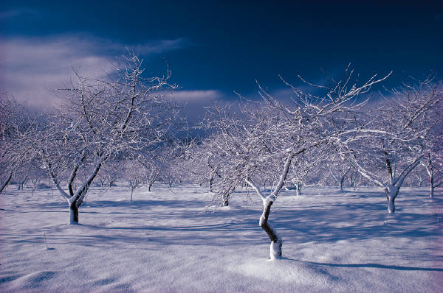 Il ___________. Il fait ____________.

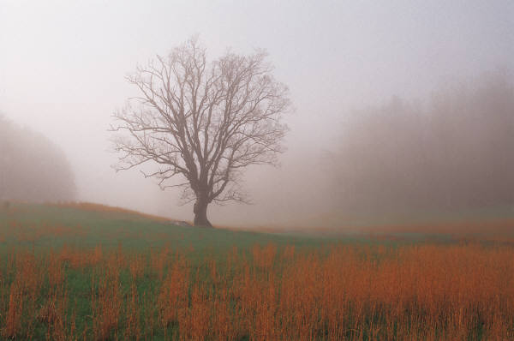 Il fait du ________________.

Il fait _____________. Il fait du _____________.

C’est un ______________.

 Il fait ____________. Il y a des _____________.

French 1
Name: _____________________
Date: ______________________
Period: _____________________
Worksheet 2:

Fill in the blanks with the correct verb conjugation and the weather vocabulary that best completes the phrase.

- Pendant l’hiver il _____ _____________.
- Il ________ __________ la semaine passée. J’ai fait du hiking.
- Il ________ du _____________ vendredi matin. Faites attention pendant que tu conduire.
- Il _______ aujourd’hui. Il ne ______ pas assez ______ pour jouer le foot.
- Le printemps il ______ ____________.
- Il y a des gens qui dissent qu’il _________ en le mois d’avril pour que nous puissions avoir les fleurs en mai.
- Ce matin il _____ du _________. Mes cheveux etaitent partout.
- Quand il _______ le mois de janvier, j’aime faire des _______ de _________.
- J’apporte mon _____________ parce qu’il ________ dehors.
- Moi, je préfère l’été parce qu’il _______ ___________ Presque chaque jour.

French 1
Name: _____________________
Date: ______________________
Period: _____________________
Worksheet 3:

Watch and listen to the conversation. Fill in the blanks with the correct statements said in this conversation about weather.

M. Rouge: Bonjour Mademoiselle.
Mlle Poulain: Bonjour Monsieur.
M. Rouge: Comment allez- ______, aujourd’hui?
Mlle Poulain: Bien. ________?
M. Rouge: Comme-ci, comme-ca. Il _______ trop _______ pour moi ce matin.
Mlle Poulain: Oui il _______ ________ pendant toute la semaine passée.
M. Rouge: Est-ce que vous avez vu la météo dans le journal?
Mlle Poulain: Non, _________ qu’il a dit?
M. Rouge: Il a dit qu’il ______ ce soir. Il ne ______ pas parce qu’il _______ trop _______.
Mlle Poulain: Incroyable! J’ai entendu qu’il ______ ___________ ce week-end.
M. Rouge: Le ________ et du _________ pendant la même semaine.
Mlle Poulain: Comme c’est étrange!
M. Rouge: Moi j’attends l’été quand il ______ __________ encore.
Mlle Poulain: Au revoir M. Rouge.
M. Rouge: Au revoir Mlle Poulain. Faisiez attention sur les rues ce soir.

